Section I: Scenario Demographics

Scenario Title: | LVAD
Date of Development: | (27/04/2018)
Target Learning Group: | Juniors (PGY 1 – 2) Seniors (PGY ≥ 3) All Groups

Section II: Scenario Developers

Scenario Developer(s): | Ashley Lubberdink MD, Sameer Sharif MD
Affiliations/Institution(s): | McMaster University
Contact Email/Twitter: | Ashley.lubberdink@medportal.ca, @SameerSharifMD

Section III: Curriculum Integration

Learning Goals & Objectives
Educational Goal: | To provide learners with the unique opportunity to manage an unstable patient with a left ventricular assist device (LVAD)
CRM Objectives: | - Effectively lead a team through the complex resuscitation of an LVAD patient  - Demonstrate high quality closed loop communication throughout the case  - Communicate with consultants early when managing an LVAD patient in the ED
Medical Objectives: | - Demonstrate a systematic approach to the assessment of the LVAD  - Recognize and verbalize the challenges with BP monitoring in the LVAD patient  - Manage the arrested LVAD patient

Case Summary: Brief Summary of Case Progression and Major Events
A 62-year-old man presents to the ED with palpitations and general malaise. On initial assessment, the team finds out he had an LVAD placed within the last 1 month. The team will need to work through how to assess the patient’s vital signs appropriately and will discover the patient has a low MAP and a low-grade fever. On inspection, the patient’s drive line site will appear infected. The initial ECG will show features of hyperkalemia. After the initial assessment, the patient will progress to a PEA arrest requiring resuscitation by ACLS protocols. Labs will reveal an acute kidney injury and hyperkalemia. The patient will obtain ROSC when the hyperkalemia is treated.

References
Pratt AK, Shah NS, Boyce SW. Left Ventricular Assist Device Management in the ICU. Critical Care Medicine. 2014;42(1)158-168.
Robertson J, Long B, Koyfman A. The emergency management of ventricular assist devices. Am J Emerg Med. 2016;34(7):1294-1301.
Bayliss,J. Mechanical Heart: a basic approach to LVADS in the ED. https://canadiem.org/lvads-approach-ed/. Accessed April 28, 2018.
Syed, S. LVAD’s 101, EM Ottawa Blog. https://emottawablog.com/2016/01/lvads-101/. Accessed April 29, 2018
Weingart, S. Left Ventricular Assist Devices (LVADS). https://emcrit.org/racc/left-ventricular-assist-devices-lvads-2. Accessed April 27, 2018
Rezaie, S. Left Ventricular Assist Device. http://rebelem.com/left-ventricular-assist-device/. Accessed April 27, 2018

Section IV: Scenario Script

A. Clinical Vignette: To Read Aloud at Beginning of Case
A 62-year-old male presents to your large community ED with a 1 day history of generalized malaise and nausea and a 2-hour history of palpitations. He is particularly concerned about his symptoms because last month he had an LVAD placed at your provinces’ major cardiac center (3 hours away) for stage 4 CHF. His wife is accompanying him but is currently parking the car.
B. Scenario Cast & Realism
Patient: | Computerized Mannequin |  |  |  |  | Realism:  Select most important dimension(s) |  |  | Conceptual
 | Mannequin |  |  |  |  |  |  |  | Physical
 | Standardized Patient |  |  |  |  |  |  |  | Emotional/Experiential
 | Hybrid |  |  |  |  |  |  |  | Other:
 | Task Trainer |  |  |  |  |  |  |  | N/A
Confederates | Brief Description of Role
ED RN | Acts as experienced RN
Patients wife (Norma) | Carrying LVAD card, has information for team re: LVAD hotline and extra set of batteries
C. Required Monitors
EKG Leads/Wires |  |  | Temperature Probe |  |  |  | Central Venous Line
NIBP Cuff |  |  | Defibrillator Pads |  |  |  | Capnography
Pulse Oximeter |  |  | Arterial Line |  |  |  | Other:
D. Required Equipment
Gloves |  |  | Nasal Prongs |  |  |  | Scalpel
Stethoscope |  |  | Venturi Mask |  |  |  | Tube Thoracostomy Kit
Defibrillator |  |  | Non-Rebreather Mask |  |  |  | Cricothyroidotomy Kit
IV Bags/Lines |  |  | Bag Valve Mask |  |  |  | Thoracotomy Kit
IV Push Medications |  |  | Laryngoscope |  |  |  | Central Line Kit
PO Tabs |  |  | Video Assisted Laryngoscope |  |  |  | Arterial Line Kit
Blood Products |  |  | ET Tubes |  |  |  | Other:
Intraosseous Set-up |  |  | LMA |  |  |  | Other:
E. Moulage
LVAD wires/battery pack, LVAD card. Pictures of drive line site to be given to learners (to show signs of infection.)

F. Approximate Timing
Set-Up: |  | 5 min |  | Scenario: | 20 min |  |  | Debriefing: |  | 20 min

Section V: Patient Data and Baseline State

A. Patient Profile and History
Patient Name: Larry Vader |  |  |  |  |  | Age: 62 |  |  |  |  |  |  |  | Weight: 70 kg
Gender: M F |  |  |  |  |  | Code Status: Full
Chief Complaint: Palpitations, general weakness
History of Presenting Illness: Over the last 1 day, general weakness/ nausea with intermittent palpitations over the last 2 hours. No chest pain. Concerned as recent surgery for LVAD placement within last month. No fevers or chills.
Past Medical History: |  | LVAD placed for NYHA4 CHF 1 month ago (LVEF 20%) |  |  |  |  | Medications: |  |  |  |  | Metformin  Warfarin  Ticagrelor
 |  | HTN |  |  |  |  |  |  |  |  |  | Ramipril
 |  | Hypercholesterolemia |  |  |  |  |  |  |  |  |  | Metoprolol
 |  | DM type 2 |  |  |  |  |  |  |  |  |  | ASA
 |  | CKD |  |  |  |  |  |  |  |  |  | Atorvastatin
Allergies: NKDA
Social History: Lives with wife. Retired accountant. Non-smoker. No ETOH/ Drug use.
Family History: N/A
Review of Systems: |  | CNS: |  |  | General weakness/malaise
 |  | HEENT: |  |  | Nil
 |  | CVS: |  |  | Intermittent palpitations x 2 hours. No chest pain.
 |  | RESP: |  |  | No dyspnea.
 |  | GI: |  |  | Mild nausea.
 |  | GU: |  |  | Nil
 |  | MSK: |  |  | Nil |  |  |  |  |  |  |  | INT: |  | Nil
B. Baseline Simulator State and Physical Exam
No Monitor Display |  |  |  | Monitor On, no data displayed |  |  |  |  |  |  | Monitor on Standard Display
HR: 80 /min |  |  | BP: 0/0 |  |  |  |  | RR: 20 /min |  |  |  |  |  |  | O₂SAT: 95 % RA
Rhythm: NSR, wide |  |  | T: 37.9ºC |  |  |  |  | Glucose: 14 mmol/L |  |  |  |  |  |  | GCS: 15 (E4 V5 M6)
General Status: Looks uncomfortable and anxious
CNS: | A +O x 3. No focal deficits
HEENT: | Nil
CVS: | LVAD hum auscultated. No pulses palpable. MAP obtainable through Doppler ± manual cuff.
RESP: | GAEB, no adventitious sounds.
ABDO: | Soft, nontender
GU: | Nil
MSK: | Nil |  |  |  |  |  |  |  | SKIN: | Drive line site erythematous and draining pus (picture to be given)

Section VI: Scenario Progression
Scenario States, Modifiers and Triggers
Patient State | Patient Status | Learner Actions, Modifiers & Triggers to Move to Next State
1. Baseline State  Rhythm: sinus, hyperkalemic (wide-complex)  HR: 80/min  BP: 0/0  RR: 20 /min  O₂SAT: 95% RA  T: 37.9ºC  LVAD on auscultation: hum/whirling sound | A+O. Feels “dizzy” and complaining of palpitations. | Learner Actions  - Monitors, IV access, glucose (14)  - Cautious IV NS/LR bolus  - ABC’s, hx and physical  - Auscultate precordium for LVAD hum  - Assess LVAD (controller, driveline, battery)  - Assess perfusion (mental status, skin temp/colour)  - Obtain MAP via manual cuff & Doppler  - Obtain LVAD info card/call hotline/caregiver (busy signal)  - Defibrillator pads placed in PA position (front and back)  - Cardiac labs, extended lytes  - ECG  - CXR  - POCUS  - ± Arterial line  - Empiric antibiotics  - Call for help (cardiology, cardiac surgery)  - Calcium gluconate 1g iv (if hyperkalemia recognized) | Modifiers  Changes to patient condition based on learner action  - If 2 x attempts NIBP RN to cue “Isn’t there something about LVAD’s and BP cuffs not working?”  - If BP assessed by manual cuff + Doppler MAP = 50 (if assessed by art line 70/40)  Triggers  For progression to next state  - All actions complete or 5 mins into the case 2. PEA Arrest
2. PEA Arrest  Rhythm: slow 3rd degree  HR: 20/min  BP: 0/0  RR: 0 /min  O₂SAT: ---  T: 37.9ºC  LVAD: no hum | Unconscious  No BP by cuff/art line | Learner Actions  - Re-auscultate chest, re-check BP manually/Doppler  - Re-check power source/connections  - Start chest compressions (30:2)  - Epi 1 amp q3min  - LVAD hotline/ Cardiology/ CV Surg called if not yet done  - Calcium gluconate 1g iv  - 1 amp D50 followed by 10 units Humulin R iv | Modifiers  - If no CPR initiated within 3 mins cardiology to call the room and recommend initiation of CPR  - In middle of first CPR cycle blood work is back  Triggers  - Calcium given 3. ROSC
3. ROSC  Rhythm: NSR  HR: 100/min  BP: 120/70 by art line, MAP 85 by doppler  RR: 16 /min  O₂SAT: 95% RA  T: 37.9ºC  LVAD on auscultation: hum/whirling sound | Patient regains consciousness, A + O, moving all 4 limbs. | Learner Actions  - Post arrest ECG  - CXR  - ICU/cardiology/cardiac surgery called (if not yet done)  - ± further hyperkalemia treatment (eg: Ventolin) | Modifiers  - After 1 min Cardiac Surgery calls back to speak to team  End case PRN

Section VII: Supporting Documents, Laboratory Results, & Multimedia

Laboratory Results
Na: 140 | K: 8.0 |  |  | Cl: 109 |  | HCO₃: 12 |  | BUN: 16 |  | Cr: 210 |  |  | Glu: 14
Ca: 2.2 |  |  | Mg: 1.1 |  |  |  | PO₄: 0.65 |  |  |  | Albumin: 35
VBG |  | pH: 7.25 |  |  | PCO₂: 35 |  | PO₂: 80 |  | HCO₃: 12 |  |  | Lactate: 2.9
WBC: 15 |  |  | Hg: 110 |  |  |  | Hct: 0.33 |  |  |  | Plt: 500
INR: 2.5
Images (ECGs, CXRs, etc.)
CXR  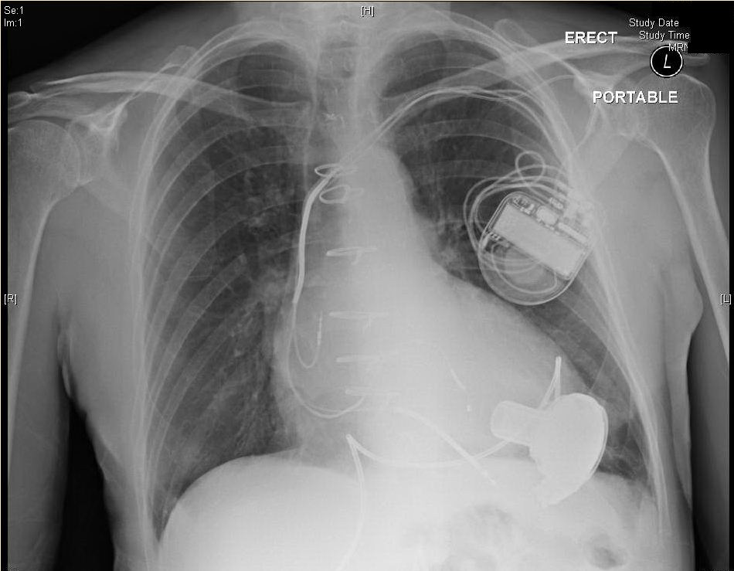  https://edecmo.org/additional-technologies/ventricular-assist-devices-vads/lvads/ | Initial ECG  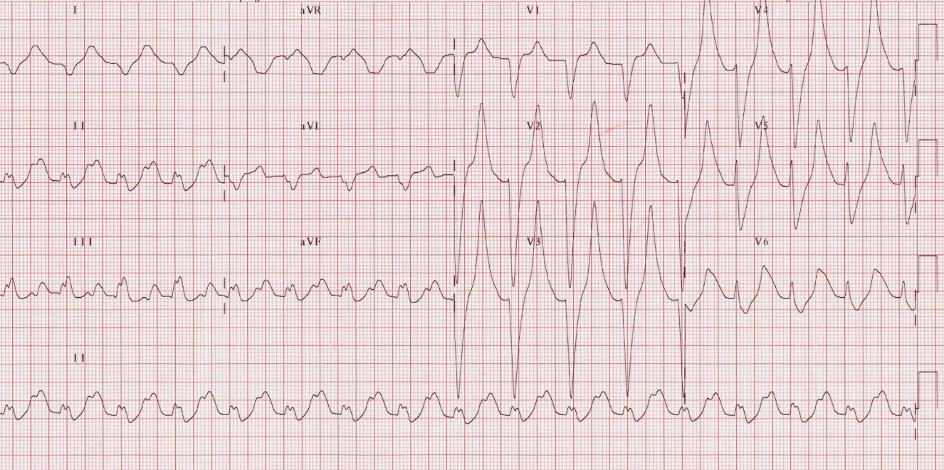  https://lifeinthefastlane.com/ecg-library/basics/hyperkalaemia/
Picture of driveline site infection  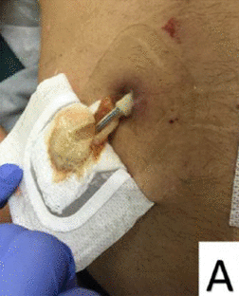  (Image source: http://journals.sagepub.com/doi/full/  10.1177/1179065217714216) | ROSC ECG  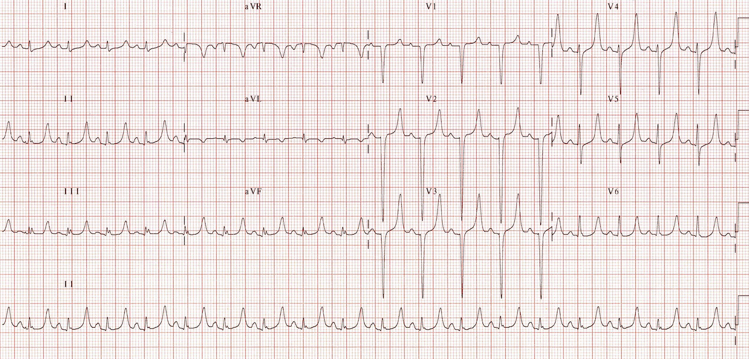  https://lifeinthefastlane.com/ecg-library/basics/hyperkalaemia/
Ultrasound Video Files (if applicable)
LVAD ECHO VIDEO:
https://www.youtube.com/watch?v=-4ThAo4m2UI

Section VIII: Debriefing Guide

General Debriefing Plan
Individual | Group |  | With Video | Without Video
Objectives
Educational Goal: |  | To provide learners with the unique opportunity to manage an unstable patient with a left ventricular assist device (LVAD)
CRM Objectives: |  | - Effectively lead a team through the complex resuscitation of an LVAD patient  - Demonstrate high quality closed loop communication throughout the case  - Communicate with consultants early when managing an LVAD patient in the ED
Medical Objectives: |  | - Demonstrate a systematic approach to the assessment of the LVAD  - Recognize and verbalize the challenges with BP monitoring in the LVAD patient  - Manage the arrested LVAD patient
Sample Questions for Debriefing
- What are the components of an LVAD?
- What are some difficulties you may encounter on the initial assessment of a patient with a LVAD?
- What is the differential diagnosis of hypotension in a patient with an LVAD?
- What are some common complications seen in patients with LVAD?
- How can echocardiography be utilized to troubleshoot LVAD difficulties?

Key Moments
Recognizing lack of utility of automated BP cuffs
Recognition of arrest and immediate initiation of ACLS
Recognition and correction of hyperkalemia

